

Tel: +44 (0)131 668 8411
Fax: +44 (0)131 668 8412
Email: vista@roe.ac.uk,
WWW: http://www.roe.ac.uk/atc/vista

Document Title: Documentation Management Plan

Document Number: VIS-PLA-ATC-00001-0001

Issue: 5.0

Date: 26 March 2002

Document  Prepared By: | Jackie McDougall  Project Assistant | Signature and Date:
Document  Approved By: | Gary Rae  Chief Engineer, UK ATC | Signature and Date:
Document  Released By: | Alistair McPherson  Project Manager | Signature and Date:

The information contained in this document is strictly confidential and is intended for the addressee only. The unauthorised use, disclosure, copying, alteration or distribution of this document is strictly prohibited and may be unlawful.

Change Record

Issue | Date | Section(s) Affected | Description of Change/Change Request Reference/Remarks
1.1 | 2/3/01 | Document Number | Document Number Changed  VIS-PLA-VPO-00001-0001 to  VIS-PLA-ATC-00001-0001
1.1 | 2/3/01 | Revisions | Revision Table inserted
1.1 | 2/3/01 | Contents | Table of Contents added
1.1 | 2/3/01 | 2.1.c | Cross reference inserted
1.1 | 2/3/01 | 2.1 | Clause d and e on issue numbering inserted
1.1 | 2/3/01 | 2.1 | Clause f was 2.2 clause b
1.1 | 2/3/01 | 2.2 | Re-written to bring in line with Q-pulse implementation
1.1 | 2/3/01 | 2.3 | Re-written to bring in line with Q-pulse implementation
1.1 | 2/3/01 | Section 3 | New section
1.1 | 2/3/01 | Annex A | VPO removed as
2.0 | 20/6/01 | 3b | File Name Convention corrected from ‘FFFFF’ to ‘DDDDD’
2.1 | 11/9/01 |  | Convert to new Template  Add Section on Filing System
2.2 | 24/9/01 | Annex C | Updating Filing procedures
3.1 | 18/1/02 | All Sections | Full Update and insertion of Drawing Procedures
4.1 | 25/3/02 | All sections | Full update

Table of Contents

1 Introduction 4
2 Acronyms and Abbreviations 4
3 Applicable and Referenced Documents 4
4 Documentation Control 4
4.1 Documentation Control Principals 4
4.2 New Document Issue and Approval Procedure 5
4.2.1 Change Control 7
4.2.2 Document Review 8
4.2.3 Distribution 8
4.2.4 Electronic File Formats 8
4.2.5 Document Numbering 8
4.2.6 Date Formats 9
4.2.7 Document Archive 9
4.3 System Documentation 9
4.3.1 Overview 9
4.3.2 Science Requirements Document 11
4.3.3 Operational Concepts Definition Document 11
4.3.4 Technical Specification 11
4.3.5 Interface Control Documents 12
4.4 Subsystem Documentation 12
5 Drawing Control 12
5.1 Drawing Control Principals 12
5.2 New Drawing Issue and Approval Procedure 14
5.3 Change Control 15
6 Electronic Source Files 16
7 VISTA Filing 17
8 VISTA E-Mails 17
Annex A: VISTA Document Numbering System 18
Annex B: VISTA Phase B Product Codes 20
ANNEX C: VISTA FILING SYSTEM 21
ANNEX D: VISTA E-MAILS 23

Introduction
This document defines the VISTA Project Office Documentation Plan. This plan describes the procedures and processes to be applied to all documentation during the life of the project.

Acronyms and Abbreviations
VPO VISTA Project Office
ESO European Southern Observatory
PS Project Scientist
CRN Change Request Notice
PA Project Assistant (Planner)
PDF Adobe Acrobat Portable Document File
WBS Work Breakdown Structure

Applicable and Referenced Documents
[AD01] VISTA Phase B Product Code VIS-PLA-ATC-00001-0009 V1.0
[RD01] ESO Interface Management Plan VLT-PLA-ESO-00000-3000 V1.0

Documentation Control

Documentation Control Principals
- Project documents are formally controlled with relation to content, naming, numbering, authorisation, distribution, access and change control.
- Procedures have been developed to ensure that co-workers, collaborators and contractors have consistent, complete and correct information and that the status of documentation is known and controlled by the VPO.
- Documents will be numbered in accordance with the numbering system detailed in Section 4.2.5.
- Issue numbers will be of the style m.n, where ‘m’ indicates an active document and ‘n’ a draft revision of the active document. For example, if issue 2.0 is the active document and a draft revision is being prepared, the issue number of this draft will be 2.1, 2.2, etc. as it is going through successive updates.
- Until a document is active, the draft versions have no significance to work in progress. For example, if issue 1.0 of a document is the active version it must be used for all work relating to that document, issue 1.2 of this document cannot be used for any purpose other than review and update of that document.
- Only documents that are active can be released outside the VPO, unless a draft requires external input.

- Most documents refer to a single system or subsystem in the Work Breakdown Structure. However, Interface Control Documents refer to two systems and special considerations applying to them. (Reference ESO Document Interface Management Plan, VLT-PLA-ESO-00000-3000).

New Document Issue and Approval Procedure
- New documents must be passed through the approval procedure before issue.
- A flow chart of the procedure is shown in Figure 1.
- The Document Approval Procedure is as follows:
- A new document is raised by the author and assigned a title and document number in the Access and Q-pulse documentation database (see the project assistant for the document number). This document is assigned a draft status and issue number 0.1.
- The document must be placed in the Q-pulse draft register prior to peer review.
- The review list is attached to the draft record in Q-Pulse.
- The draft is subject to peer review and may be returned to the author for updating.
- Following completion of any revisions to the draft and peer review acceptance, the document is forwarded for approval. At this point no further changes can be made to the document unless required for approval.
- The document will either be approved or returned to the author for further revision.
- Once the document has been approved it is assigned the status issue 1.0 and is activated. The document front page will be signed off in accordance with Table 1.
- An agreed distribution list will be drawn up for the document and entered into Q-pulse as a ‘signed’ pdf file. The document will have the individuals’ signatures page embedded into the pdf document by the PA.
- The original MS-Word version will be filed in a secure directory under the control of the Project Assistant. These documents will not hold signatures.
- The document will be issued to the attached distribution list.

Table 1 : Document Front Page Approval Table

Prepared: | the author of the document
Approved: | the person who approves the document, e.g. a project engineer, systems engineer or commercial manager within the VPO or other company or organisation
Released: | the person who releases the document, e.g. the Project Manager
Reviewed: | the person who (in some cases) reviews the document, normally the PS
Figure 1: Document Approval and Document Change Control Flowcharts
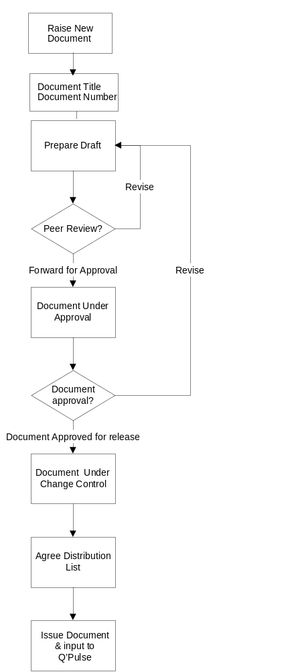
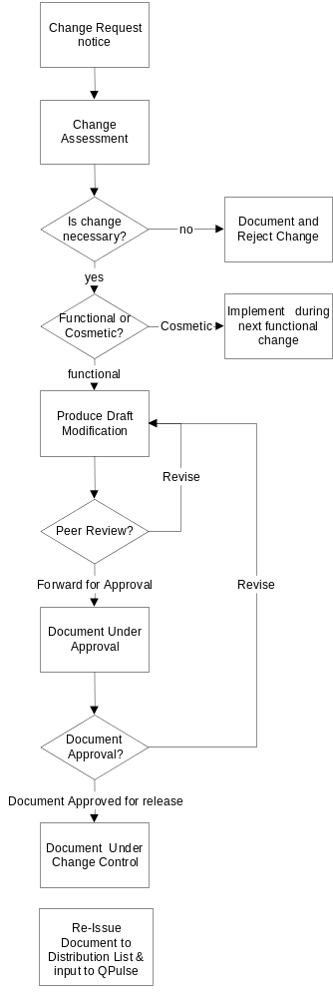

Document Approval Flowchart

Document Change Control Flowchart

Change Control
New versions of documents will be controlled in a similar way to new documents. A flow chart of the procedure is shown in Figure 1.

The Document Change Control Procedure is as follows:

- If a change to a document under change control is deemed necessary, the person identifying such a change must submit a Change Request Notice (CRN) to the VPO or attach a change request in Q-pulse.
- The VPO will assess the request to determine if it is necessary.
- If the change is considered unnecessary the reasons for rejecting the change will be documented and the request closed. The author of the CRN will be informed of the decision and reasons for rejection.
- If a change is necessary, it will be further assessed to determine if the change must be implemented immediately (functional change) or can wait (cosmetic change).
- If it is a cosmetic change, the request will be kept active and implemented during the next functional change to that document.
- Active cosmetic requests will be reviewed periodically to determine if their status has changed, any change that has not been implemented within three months of request will be given the status of a functional change.
- If the change is a functional change, a draft of the document will be released for revision.
- The draft is subject to peer review and may be returned for revision.
- Following completion of any revisions to the draft and peer review acceptance, the document is forwarded for approval. At this point no further changes can be made to the document unless required for approval.
- The document will either be approved or returned for further revision.
- Once agreed, the document revision will be signed off in accordance with Table 1 and the issue number will be updated to the next active number i.e. 2.3 is approved and the issue number raised to 3.0 and the document placed under change control within Q Pulse.
- The PA will ensure that the relevant signed cover sheet is pasted onto the PDF format document.
- The document will be activated and re-issued to the distribution list.
- Every revised document that is formally released will include a revision page with the following information:

- Section/page affected
- Reason/description/remarks
- Change request reference if relevant
- Date of change
- Issue number change was implemented under

Document Review
- All documents will be reviewed using the approval procedure.
- Documents will be subject to further review in the development of the VISTA design. Changes required, as a result of such review, will be subject to raising a change request.

Distribution
- Each document or category of documents will be distributed as decided by the Project Manager.
- Documents will be distributed either in paper form or in an electronic format that does not easily allow their modification ie PDF. This is to minimise the risk of unofficial versions of documents being produced.

Electronic File Formats
- Formally released documents distributed electronically will be in PDF (Adobe Acrobat’s Portable Document Format).
- The Project Office will use the Microsoft Office Suite as the standard source format of electronic documents. At the Project Manager’s discretion, some documents may use other source formats, eg MathCAD.
- Source documents produced external to the Project Office may also use other formats such as LaTeX.

Document Numbering
- All VPO documents will be numbered according to the system presented in Annex A.

Date Formats
- Dates will be formatted in an unambiguous manner, bearing in mind that US and European styles differ. The following formats are acceptable:
dd-mmm-yyyy e.g. 25 August 2000 (preferred)
dd/mm/yy e.g. 25/08/00

Document Archive
- An electronic archive will be maintained of all document released versions. The archive will be the responsibility of and can only be accessed by request to the Project Assistant. The PA will keep two archives, a PDF version held within Q-Pulse and MS-Word version held within a restricted archive directory.

System Documentation

Overview
- Throughout the progress of the project, many documents will be produced within each work package and within different disciplines. Although it is not possible to list in advance all the documents that will be produced, it is necessary to define what types of document will be produced.

Figure 2 Hierarchy of important system and package documents
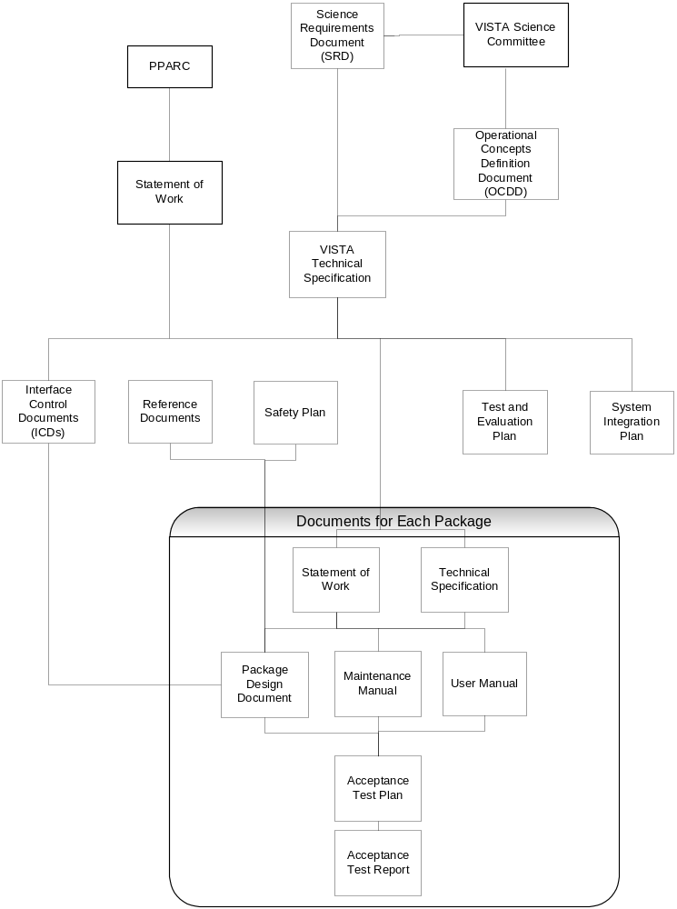

Science Requirements Document
- The VISTA Science Requirements Document defines the top level requirements of the project in a manner that is independent of the design, but that is believed to be technically achievable. By comparison with other projects, the goals should also potentially be achievable within the budget, but this cannot be assumed.
- The SRD is the responsibility of the Project Scientist, who represents the requirements and aspirations of the VISTA Consortium and is subject to approval by the VSC and VPMC. It was placed under change control on release. Any changes will be likely to have cost or schedule implications and will only be possible under Control Change Procedures.

Operational Concepts Definition Document
- The Operational Concepts Definition Document defines how VISTA will be used and operated. It includes the Design Reference Program, which is necessary to evaluate the speed of VISTA’s surveys, a parameter to be maximised in design. The OCCD defines operational and observational scenarios at an early stage in the conceptual design. It is the key document that allows design trades to be made to meet operational requirements. It is fundamental to the design and user interface of the software deployed at the telescope.
- This document is the responsibility of the Project Scientist. It is under change control. Since operational procedures at Paranal and the UK VISTA Data Centres are likely to evolve further, it is likely that this document will undergo several revisions throughout the project. Each change will be assessed for cost and risk impact.

Technical Specification
- The Technical Specification has been derived from the SRD, OCDD and output from Phase A to provide engineers with the requirements for the design of VISTA. The Technical Specification is the responsibility of the VISTA Systems Engineer. It should completely specify the requirements from an engineering point of view, though the SRD and OCDD may still be referred to by the engineers for clarification.
- The Technical Specification is under change control. At the end of Phase A it was completed and signed off by the VPO and the VPMC. After this date changes will still be possible but will be subject to a rigorous procedure to assess cost, timescale and risk implications under the Change Control procedures.
- Following a systems functional definition, the Technical Specification splits the system up into a number of subsystems and describe the functionality of each system. It will not describe alternative solutions that were rejected; these are described in separate Technical Notes.

Interface Control Documents
- Interface Control Documents will define in detail the interfaces between each pair of systems that have some connection. Each ICD will be the responsibility of the manager of one end of the interface, but must be approved by the manager of the system at the other end. All ICDs must be approved by the Systems Engineer.
- ICDs will be identified by two numbers generated from an N’squared diagram, based on the Phase B Work Breakdown Structure. These numbers will be issued by the Systems Engineer.
- Change control is particularly important for ICDs and will be rigorously adhered to, ensuring that all parties involved are fully involved in any proposed changes.
- Some systems, especially software, may have an interface that is essentially public, eg one-to-many or publish/subscribe. In this case the manager of any system at the “many” end, must register an interest with the manager of the “one” end and this fact must be recorded in the ICD and the distribution mechanism.

Subsystem Documentation
- From the system design, a number of subsystems or packages will be worked upon independently. Each package will require the following documents:
- Technical Specification
- Statement of Work
- User Manual
- Maintenance Manual
- Technical Notes
- Trade Study Reports
- ICDs to all relevant external systems
- Internal ICDs (the responsibility of the work package manager)
- Acceptance Test Plan
- Acceptance Test Report
- The dependence hierarchy of these and system-wide documents is illustrated in Figure 2.

Drawing Control
Engineering drawings are project documents which differ from the normal documents covered by this plan and as such, there are some differences which apply to the procedures for the issuing and control of drawings.

Drawing Control Principals
- Drawings will be numbered in accordance with the numbering system as detailed in Annex A.
- Upper case letters will be used for recording issues of drawings eg Issue A.
- Draft revisions of drawings before formal release will have the text banner located above the drawing title block eg.
provisional drawing – not valid for manufacture

- Drawings which display the provisional drawing text banner will have no significance to work in progress.
- For the first formal issue of a drawing the following procedure shall be followed:
- The provisional text banner will be removed from above the drawing title block;
- The letter A will be added to the issue box in the drawing title block;
- The text “first issue” will be added to the last modification box in the drawing title block.
- Only issued drawings can be released outside the VPO, unless a provisional drawing requires external input. Drawings which are released outside the VPO will normally be in PDF format.
- Most drawings refer to a single system or subsystem in the work breakdown structure. However, as for interface control documents interface control drawings refer to two (or more) systems and special considerations apply to them.
- Interface control drawings will be numbered in accordance with section 4.3.5.

Example: VIS-DWG-ATC-DDDDD-GGGG

- Electronic files of drawings (including 3D solid models) are stored by top level product Code number under the following directory path:

H:/VISTA/Work Breakdown Structure/Product codeNo./Drawings…
/Current
/WIP
/Superceded
/Approvals

Where the directory folders are used as follows:

Current For all approved drawings, this folder shall be Read Only.

WIP For new drawings which have not been approved and for drawings under revision.

Superceded For archiving previous issues of current drawings, this folder shall be Read Only.

Approvals For storing the approval/change record sheets (Word documents) associated with each drawing.

New Drawing Issue and Approval Procedure
- All drawings must be approved prior to issue.

- The drawing approval procedure is as follows:

- Drawing numbers as required will be assigned by the project planner from a drawing database which is held separate from the documentation database.

- In accordance with Appendix A all drawings with the exception of interface control drawings will be numbered as such:

VIS-DWG-CCC-DDDDD-GGGG

- The database will have a field to identify the origin of the drawing. This will form part CCC of the drawing number.

- Contractors supplying drawings to the project must comply with the VISTA drawing numbering system. Numbers will be allocated in blocks as required by the PA.

- The database will have a field to identify what the origin format of the drawing is ie. ACAD, ProE, etc.

- The part of each drawing number GGGG will be allocated sequentially within each product code group DDDDD starting from 0001 regardless of whether that number has been used in the documentation database. Therefore it is entirely possible that a drawing and a document may appear to have almost identical numbers differing only in the identification of the document type.

Example : VIS-DWG-ATC-01000-0001 and VIS-SPE-ATC-01000-0001

- Each drawing will have an approval/change record document associated with it. This document carries the same number as the drawing and will be circulated with the drawing for peer approval and should be signed and dated by the following personnel:

Drawn By: The originator of the drawing

Checked By: An appropriate person nominated to check the drawing

Approved By: There can be more than one person nominated to approve a drawing and are usually the Project System Engineer and an appropriate Project Engineer.

Released By: The person nominated to release the drawing usually the Project Manager.

- The drawing approval/change record should be signed in the order above.

- Once the drawing has been approved the initials of the signatories should be added to the drawing title block and the drawing saved to the appropriate WBS current folder

- A PDF version of the file should be forwarded to the Project Planner along with the signed approval/change record sheet for filing in Q’pulse.

- Drawing files will be filed in Q’pulse as VISD-DDDDD-GGGG in order to differentiate between other documents.

- Each drawing will be distributed as decided by the Project Manager and Project Systems Engineer. The distribution list shall be included in the Q’Pulse database.

Change Control
Every drawing formally issued as per 5.2 is subsequently under change control. Any changes to that drawing must be through the change control procedure as defined in 4.2.1

The procedure for implementing revisions to current drawings is as follows:

- Once a change request to a current drawing has been approved the electronic file is copied from the Current directory to the Wip directory and saved as:

VIS-DWG-CCC-DDDDD-GGGG_(next issue letter)

- The text “Drawing under revision – draft 1”is added to the status banner above the title block by the person responsible for modifying the drawing.

- The drawing/file should be kept in this directory and worked on until it has been approved for reissue.
- The changes implemented to the drawing should be recorded in the change record table of the approval document along with the CRN if applicable.

- The CRN should also be recorded in the title block of the drawing along with a brief description of the change.

- When the drawing is ready for reissue it should be circulated with its associated approval/change record document for approval signatures (as per the procedure for the issue of a new drawing) with the addition of a signature for the person modifying the drawing.

- If any subsequent changes are required to the drawing after it has been circulated for approval then the status text banner should be updated to “Drawing under revision – draft 2” and circulated again for approval.

- Once the drawing has been approved for reissue the title block of the drawing should be updated as follows.

- Remove status text banner
- Add next issue letter
- Add initials of signatories
- Add last modification information and CRN

- A PDF version of the file is forwarded to the Project Planner along with the signed front sheet of the approval/change record document and the electronic file for filing in Q’pulse.

- The new file will be saved to the appropriate current directory.

- The previous issue will be moved to the appropriate superceded directory.

- Each drawing will be distributed to the distribution list in Q’pulse as amended by the by the Project Manager and Project System Engineer.

Electronic Source Files
- Electronic source files of official documents must reside in the documentation management section of Q-pulse.
- File naming convention in Q-pulse is as follows VIS-DDDDD-GGGG, where DDDDD is the product code and GGGG is a numerical series within that code as defined in Annexes A and B.
- Documents will be filed in Q-pulse under document type: VIS/WW “work breakdown title” (e.g. VIS/01 Telescope) where WW is the level one WBS.
- The project planner is responsible for placing all files in Q’pulse.
- Drawings distributed electronically will be in PDF format.
- The VPO will use Autocad and Autodesk Inventor (for 3D models) as the standard source format for drawings.
- Drawings produced externally to the VPO may use other formats only with the approval of the VPO. Such formats must be transferable and interchangeable with the VPO.
- Paper copies of drawings will normally be printed on A3 size. As such drawings should not be scaled from.
- The standard sheet sizes to be used will be A3, A2, A1 and A0. Template drawing borders and title blocks have been prepared.
- Contractors may use their own drawing borders provided there is a reference to VISTA in the title block and the drawing numbering is as per this document.
- The naming of drawing files shall be:

VIS-DWG-CCC-DDDDD-GGGG_sht1_A.file extension

VISTA Filing
All correspondence to and from the VPO will be stored in full in a centralised filing system. This system will be managed and controlled by the Project Assistant. A full explanation of the filing system can be found in Annex C.

VISTA E-Mails
All incoming and outgoing e-mails that are of commercial importance will be printed and filed in the centralised filing system according to the relevant Work Breakdown Structure product code. On a monthly basis e-mails will also be archived chronologically to CD and separate back-ups maintained. These systems will be managed and controlled by the Project Assistant. A full explanation of the E-mail filing system can be found in Annex D.

Annex A: VISTA Document Numbering System

VISTA's Document Numbering system is based on ESO's VLT Documentation Plan, VLT-PLA-ESO-00000-0005, Draft B, 5 July 1991.
The format for all VISTA documents is:
VIS-BBB-CCC-DDDDD-E-FFFFFF-GGGG
BBB is type of document. Current applicable BBB codes:
PLA |  | Plans
SPE |  | Specification
SOW |  | Statement of Work
TRE |  | Technical Report
MIN |  | Minutes of Meetings
MAN |  | Manual
MEM |  | Memo
CRE |  | Change Request
INS |  | Instruction
DWG |  | Drawing
AMD |  | Format of Amendments
RFW |  | Request for Waiver
DNO |  | Discrepancy Notice
SCH |  | Schematic/layout/diagram
ICD |  | Configuration Data Item List
CCC is identified of company/organisation. Applicable CCC codes:
ATC |  | VPO and UK ATC specific documents
VSC |  | VSC/Project Scientist ownership
VEB |  | VEB ownership
ESO |  | ESO documentation specific to VISTA
EAG |  | Executive Agency ownership
VPMC |  | VISTA Project Management Committee ownership
DDDDD is product code, which will tie into the overall WBS as defined in Annex B. For phase A work we will use the following:
00000 | Top Level documentation
00001 | Project Management
00002 | Systems Engineering
00003 | Monthly Reports
00004 | VEB/VPMC Reports
00005 | General Design
00006 | Procedures for WPM’s Monthly Reports
00007 | to be assigned
00008 | To be assigned
00009 | to be assigned
00110 | General Optical Design documents
00111 | f/2.5 Optical documents
00112 | f/1 Optical documents
00113 | Cold stop documents
00114-00119 | to be assigned to optical systems
00120 | Mechanical Documents
00121 | Brian Mack reports
00122-00129 | Mechanical Documents
00130-00139 | Electronics/detector documents
00140-00149 | Control documents
00150-00159 | Software documents
00160 | Design Validation Review November 2000
00170 | Scrutiny Panel – December 2000
00180 | Instrumentation CoDR July 2001  – Both IR & Visible Instruments
E is the replica number and can be E, or EE or EEE. This will be applicable for test reports on things like the CCDs, but will generally not be used.
FFFFFF is the product breakdown code. This is an extension of the DDDDD code and will not be used until a need is identified.
GGGG is a four digit sequential number in each DDDD and FFFFFF sub-group.

Annex B: VISTA Phase B Product Codes
Five digit product codes are based on the Phase B Work Breakdown Structure:

- digits 1 and 2 Level 1 WBS in the format 01, 02 etc
- digits 3 and 4 Level 2 WBS
- digit five reserved for level 3 WBS.

The product codes can be found in document VIS-PLA-ATC-00001-0009.

ANNEX C: VISTA FILING SYSTEM

- All incoming VISTA mail will be opened, date stamped and a File Reference number applied by the Project Assistant and Administration Assistant.

- The mail will then be logged in the “Mail Logging Book”, detailing the following:

- Arrival Date
- Their Date
- External Reference
- Subject
- VISTA File Reference Number (see below)

- Each document will be stamped showing the following:

- File Reference Number and Folio Number
- File Category
- Date Received
- Circulation List
- Instructions for Action

- The master document will be photocopied and distributed to those listed on the circulation list. These copies then become the property of the recipient

- The master document will then be filed. A unique file number and a folio number will address it.

- Numbering of files: Files will be numbered according to the relevant five digit Work Breakdown Structure code. For example, 01000 will be the file for the Telescope.

- Folio Numbers: Each document within a file will be given a unique folio number – eg F1, F2, F3, etc.

- Therefore an example document reference number would be 01000/F16 (Telescope/Folio No 16).

- If a particular file grows to a level where it is necessary to split it into separate files, then the Level 2 WBS codes will be applied and reference to the removed folio documents will be made in the original file eg:

Folio Numbers 12, 14, 21, 27 from File No. 01000 (Telescope) that are relevant to the Elevation Drive are now filed in 01060 (Elevation Drive)

- Should there be any actions or comments arising from new mail, the recipients should document these via e-mail, quoting the File Reference Number and Folio and any relevant heading in the e-mail subject field. These comments/actions must be copied to everyone detailed in the circulation list (and anyone else if relevant) and to VISTA mail.

- Any actions/comments made by e-mail and copied to VISTA mail will then be printed, a File Reference and Folio number applied to the e-mail and filed in the relevant file.

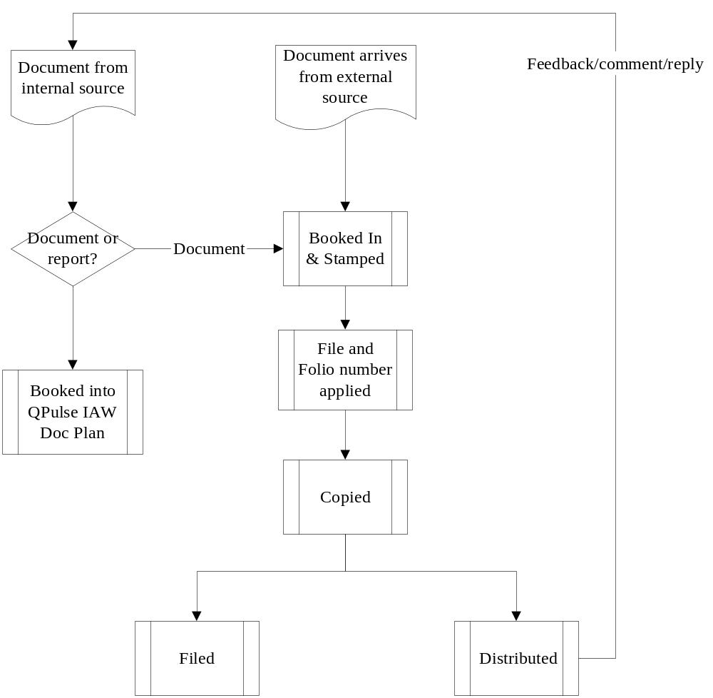

ANNEX D: VISTA E-MAILS

- All internal and external e-mails that are commercially relevant to VISTA, must be copied to the VISTA e-mail directory.

- All e-mails must state in the subject header the relevant Work Breakdown Structure product to define where it should be filed.

- If available, the subject header must also quote the WBS file reference and folio number, to allow the e-mails to be filed with the relevant correspondence.

- All relevant VISTA e-mails will be printed and filed in the appropriate document file on a daily basis.

- On a monthly basis, all relevant e-mails will be copied to CD chronologically and a back-up copy maintained by the Project Assistant and Administration Assistant.

__oOo__

